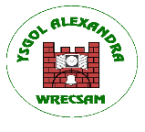
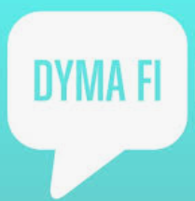 Dyma Fi 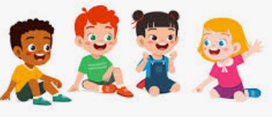
Homework Grid
It would be lovely if you could take some time with your child to have a go of at least 3 activities that are related to what your child will be doing in school as part of their topic
Please send any pictures of your work via Seesaw. We are really looking forward to seeing what you can do!
Expressive Art
Activity 1- Hand on Paper
- Put the child’s hand on paper and draw around it.
- Let them feel or scribble on the outline.
Activity 2- Clap with Me
- Adult claps hands slowly, then waits.
- Child can watch, smile, vocalise, or try to clap.
Activity 3- Mirror Play
- Sit with the child in front of a mirror.
- Point to their face and say “eyes,” “nose,” “mouth.”
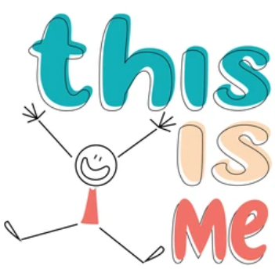

Mathematics and Numeracy
Activity 1 – Use your favourite doll or teddy to find different parts of the face/body. Can you move around your house using the language of On/Under or Infront/Behind/ Next? Does your child enjoy seeing their favourite toys in different places? Can your child imitate your actions or place their toys in different places following instructions e.g. teddy on?
Activity 2- Can you use the sign and symbol for more or help during everyday activities? If your child is enjoying an activity can you pause it to see how they request more before modelling the correct sign?
Activity 3- Counting Fingers and Toes- Adult gently touches each finger or toe, saying “one… two… three…”. The child can watch, laugh, wiggle, or pull their hand/foot away.
Activity 4- Roll and Count- Adult rolls a big soft dice (or uses a cup with 1–3 objects inside). Count the dots or objects together slowly. A child can bang the dice, watch, or take out objects.
Activity 5- 3. 1 Car, 2 Cars- Adult pushes one car and says, “one car.” Then pushes two cars and says “two cars.” A child can watch, push, or copy.

h
Language, Literacy and Communication
Activity 1- Object of Reference- Show a familiar object (cup, teddy, shoe). Say the word slowly: “Cup.” “Teddy.” “Shoe.” Give the object to the child to hold or explore.
Activity 2- Look at yourself in the mirror. Can you have a go at making different facial expressions in the mirror? Can you place of different hats/ glasses? Start with a simple face. Ask your child to make a happy face or smile, or have your child identify your simple happy facial expression. Vary the facial expressions by labelling them as you make them e.g. sad/ happy/ angry.
Activity 3- Can your child make a choice during mealtimes? Offer them (when appropriate) a choice e.g. offer them juice or water, show them both choices and ask them to choose, can they vocalise or gesture to which they want?
Activity 4- Family Photo Talk- Show the child a family photo (e.g., of themselves, sibling, parent). Say: “That’s you… that’s Mum… that’s Dad.” Encourage pointing, touching, or looking.
Activity 5- Name Song- Sing a simple song using the child’s name, e.g., “Hello, (Name)” or “Goodnight, (Name).” Encourage the child to smile, clap, or vocalise.
Activity 6 – Family portrait – Can the children name and draw and label the family members and pets living in their house?

