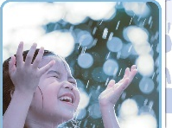
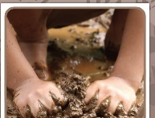
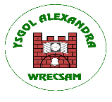
Our world and Beyond
Homework Grid
It would be lovely if you could take some time with your child to have a go of at least 3 activities that are related to what your child will be doing in school as part of their topic
Please send any pictures of your work via Seesaw. We are really looking forward to seeing what you can do!
Expressive Art
Activity 1- Water/ Ice art
Use a bowl of water or ice cubes and a paintbrush or sponge. Adult dips and makes marks on paper or the ground and says “water.” Can your child watch, splash, dip, or copy the action?

Activity 2- Clap with Me
- Adult claps hands slowly, then waits.
- Child can watch, smile, vocalise, or try to clap.
Activity 3- Mirror Play
- Sit with the child in front of a mirror.
- Point to their face and say “eyes,” “nose,” “mouth.”

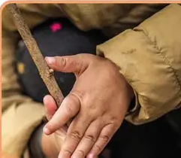
Mathematics and Numeracy
Activity 1 – Use your hands or a toy car. Say “ready,” pause, say “steady,” pause, then say “go!” and move the toy or clap. Repeat the routine. Does your child watch, smile, or copy the action when you say “go”?
Activity 2- Can you use the sign and symbol for more or help during everyday activities? If your child is enjoying an activity can you pause it to see how they request more before modelling the correct sign?
Activity 3- Use small objects such as toys, spoons, or blocks. Place one item and say “one.” Then place two items and say “two,” up to five. Can your child look, touch, or help place the items?
Activity 4- Adult jumps once and says “one jump.” Then jumps twice and says “two jumps,” up to five. Does your child enjoy watching or copying the movements?
Activity 5- Use water in the bath or sand in a tray. Scoop one cup and say “one.” Then scoop two cups and say “two,” up to five. Does your child enjoy the sensory play? Can they help scoop or pour? 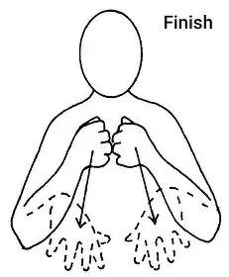

h
Language, Literacy and Communication
Activity 1- Provide paper and crayons, pencils, or felt tips. Adult makes a mark and says “mark.” Can your child watch, touch, scribble, or make their own marks? Any movement on the page is learning.
Activity 2- Look at yourself in the mirror. Can you have a go at making different facial expressions in the mirror? Can you place of different hats/ glasses? Start with a simple face. Ask your child to make a happy face or smile, or have your child identify your simple happy facial expression. Vary the facial expressions by labelling them as you make them e.g. sad/ happy/ angry.
Activity 3- Can your child make a choice during mealtimes? Offer them (when appropriate) a choice e.g. offer them juice or water, show them both choices and ask them to choose, can they vocalise or gesture to which they want?
Activity 4- Use water in the bath or sand outside. Adult pours or scoops and says simple words like “in,” “out,” “more,” or “stop.” Can your child watch, copy the action, or show enjoyment through movement or sound?
Activity 5- Name Song- Sing a simple song using the child’s name, e.g., “Hello, (Name)” or “Goodnight, (Name).” Encourage the child to smile, clap, or vocalise.

